Name: | ___________________________________________________ |  |  |  | Date: ___________
 | Year 9 Mathematics  Investigation 3, 2015  Topic – Area and Volume of Similar Figures  Take home component
Date out: |  | Week ____ Date _____________ | Date Due: | Week ____ Date _____________
AIM: In this assessment, you will be investigating the area and volume of similar figures.

Important Note: The amount by which a side length is multiplied or divided to get the new side length is called the scale factor. For example, if the side length of the original object is 10 cm, and the side length of the new image is 20cm, we would say that the original object has been enlarged by a scale factor of 2. Scale factor can also be written as a simplified ratio – original side : image side.

1. | Similar figures are figures that have all angles equal, and sides in equal ratio. Consider the similar triangles below:
 | 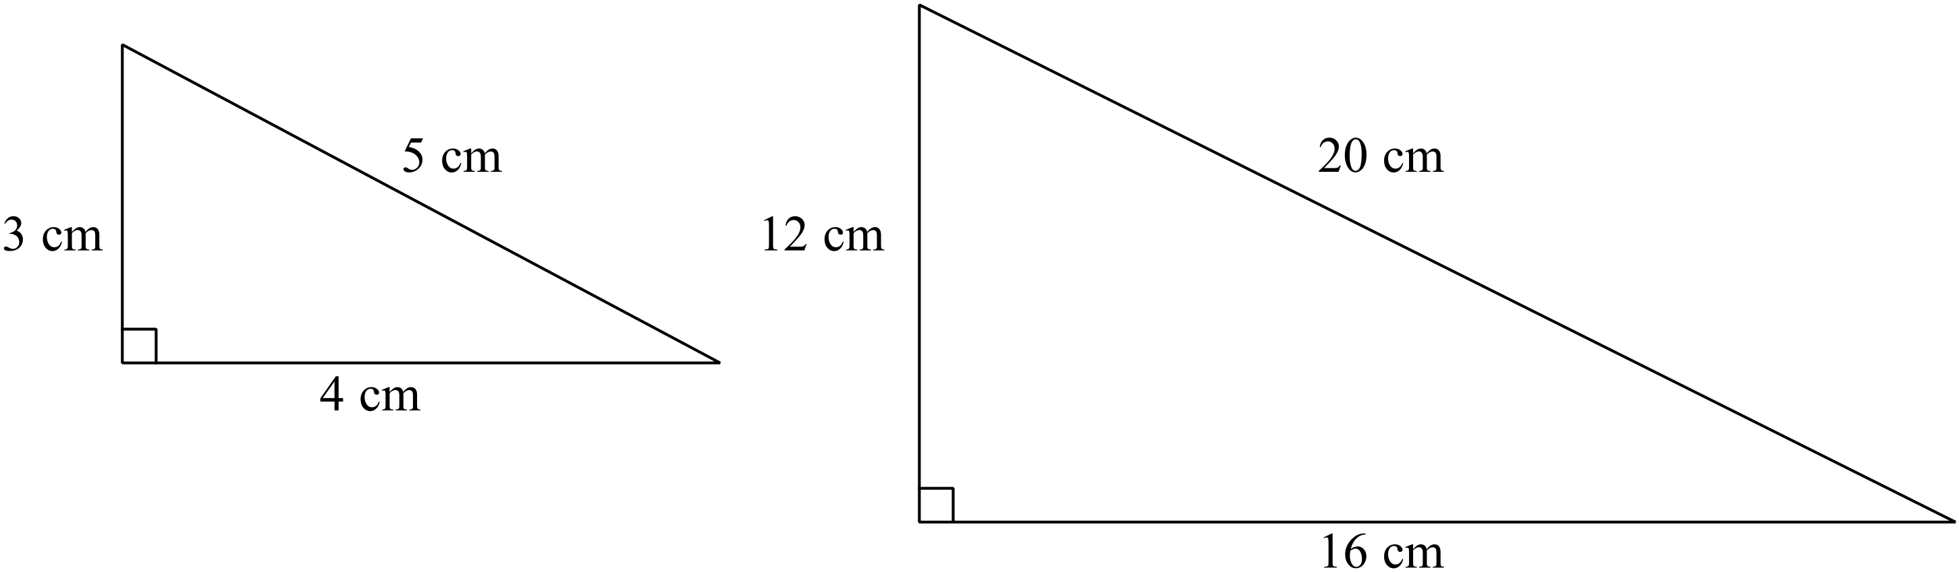
a) | By what scale factor were the side lengths of the smaller triangle increased to get the larger triangle?
b) | Calculate the perimeter of the smaller triangle.
c) | Calculate the perimeter of the larger triangle.
d) | Calculate 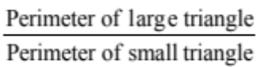
e) | Explain the relationship between the answers to parts (a) and (d).

2. | All squares are similar to each other. Consider the squares below:
 | 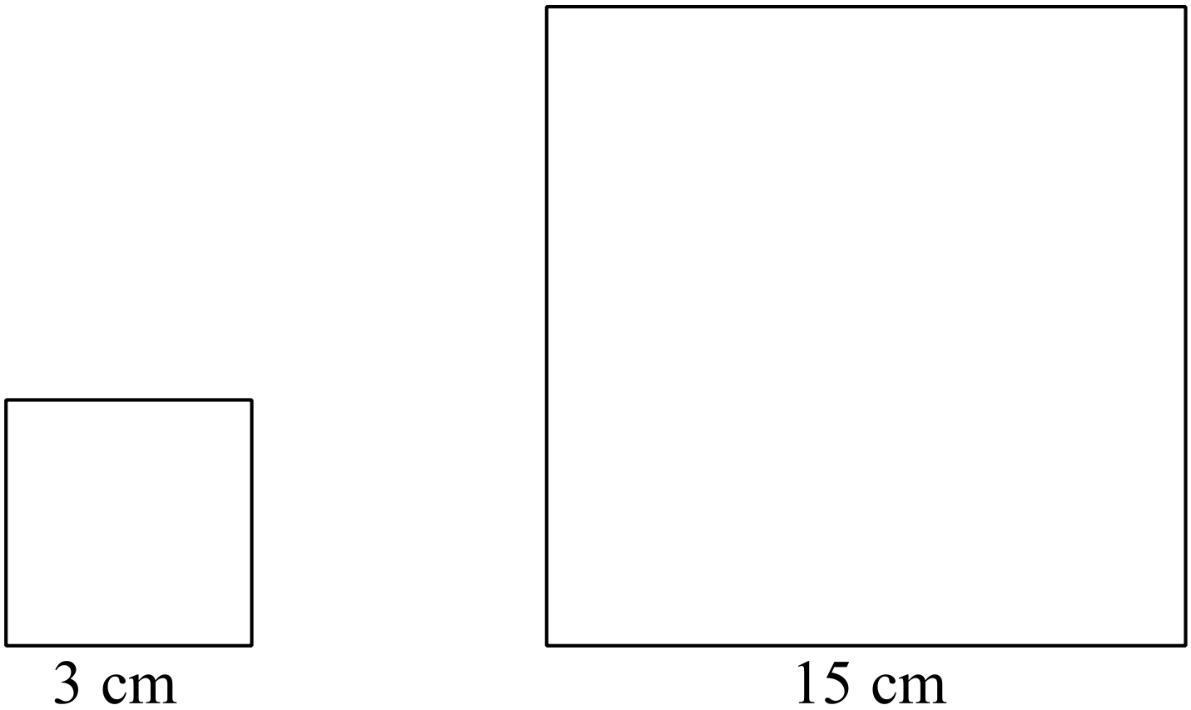
a) | By what scale factor were the side lengths of the smaller square increased to get the larger square?
b) | Find the perimeter of both of these squares.
c) | Calculate 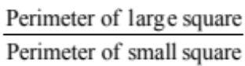
d) | Explain the relationship between the answers to parts (a) and (c).

3. | Consider the similar figures below:
 | 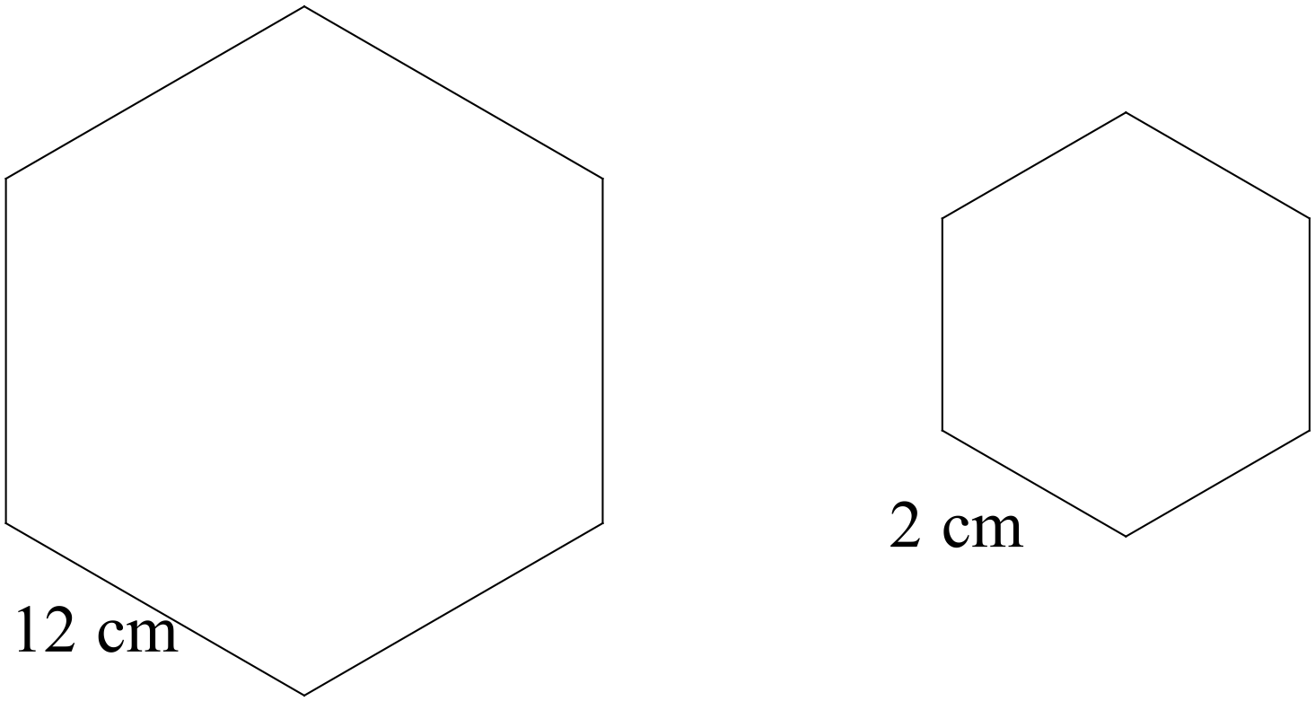
a) | By what scale factor were the side lengths of the larger figure decreased to get the smaller figure?
b) | What will be the scale factor of the perimeters for these figures?
c) | If the perimeter of the larger figure is 72 cm, what will be the perimeter of the smaller figure?

4. | Consider the similar triangles below:
 | 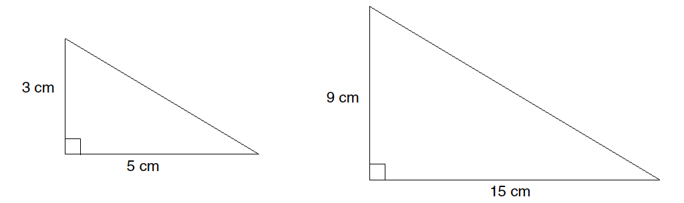
a) | By what scale factor were the side lengths of the smaller triangle increased to get the larger triangle?
b) | Calculate the area of the smaller triangle.
c) | Calculate the area of the larger triangle.
d) | Calculate 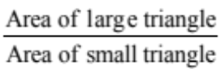
e) | Explain the relationship between the answers to parts (a) and (d).

5. | Consider the squares below:
 | 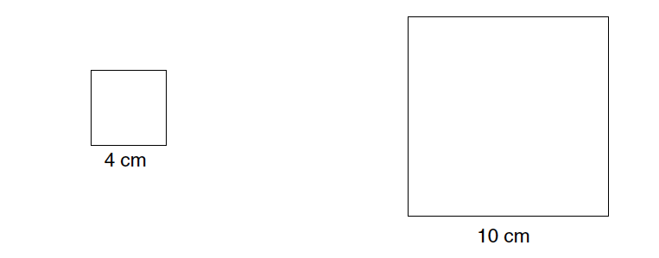
a) | By what scale factor were the side lengths of the smaller square increased to get the larger square?
b) | Find the area of both of these squares.
c) | Calculate 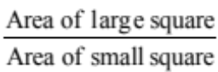
d) | Explain the relationship between the answers to parts (a) and (c).

6. | Consider the similar figures drawn below:
 | 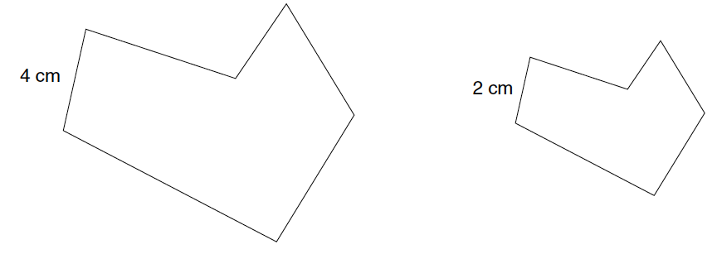
a) | By what scale factor were the side lengths of the larger figure decreased to get the smaller figure?
b) | What will be the scale factor of the areas for these figures?
c) | If the area of the larger figure is 80 cm², what will be the area of the smaller figure?

7. | Now consider the following two cubes. All cubes are similar to each other.
 | 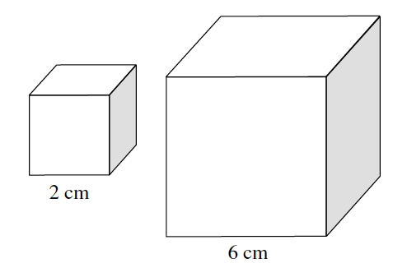
a) | By what scale factor were the side lengths of the smaller cube increased to get the larger cube?
b) | Find the volume of the smaller cube.
c) | Find the volume of the larger cube.
d) | Calculate 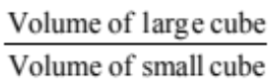
e) | Explain the relationship between the answers to parts (a) and (d).

8. | Below are two similar rectangular prisms:
 | 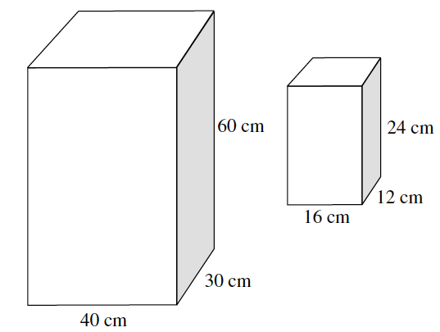
a) | By what scale factor were the side lengths of the larger prims decreased to get the smaller prism?
b) | Calculate the volume of each prism.
c) | Calculate 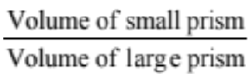
d) | Compare the ratio of the volumes to the ratio of the sides. What do you notice?

9. | Here is a trophy awarded to the owner of the horse that wins the Imaginary Cup. Let’s assume the trophy is valued at $60,000.  The winning jockey receives a miniature trophy similar to the owner’s trophy, with sides in the ratio 1:3. | 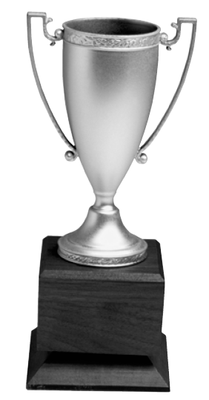
a) | What will be the scale factor of the volumes between the jockey’s trophy and the owner’s trophy?
b) | Assuming the value of the trophy is based on its volume, what will be the value of the miniature trophy given to the winning jockey?

